Assignment on Evolution of SIX Effector Genes in Fusarium oxysporum

1. Background and Objective
Fusarium oxysporum is a genetically diverse fungal species complex containing numerous pathogenic lineages adapted to different plant hosts as well as nonpathogenic isolates. The species complex is characterized by strong host specialization, where different formae speciales are associated with specific hosts and disease outcomes (van Dam et al., 2016). A major factor contributing to host adaptation and pathogenicity is the presence of lineage specific effector genes located on accessory, or pathogenicity, chromosomes (Ma et al., 2010).
Among these effectors, the Secreted In Xylem (SIX) proteins represent an important group of small secreted proteins involved in F. oxysporum plant interactions (Rep, 2005). SIX genes were initially identified from the xylem sap of tomato infecting F. oxysporum f. sp. lycopersici (Fol), and several members of this gene family have been associated with virulence, host specificity, and avirulence responses through interactions with plant resistance genes (Houterman et al., 2008; Jangir et al., 2021). Different F. oxysporum lineages possess distinct combinations and copy numbers of SIX genes, making these genes valuable markers for studying pathogen evolution and host specialization (van Dam et al., 2016; Jangir et al., 2021).
The evolutionary history of SIX genes is complex because they may be shaped by multiple processes, including vertical inheritance, gene duplication and loss, sequence divergence, and movement of accessory genomic regions between lineages. In F. oxysporum f. sp. lycopersici, SIX genes are located on pathogenicity associated accessory chromosomes, which have been shown to contribute to host specificity and can be transferred between strains under certain conditions (Ma et al., 2010; Li et al., 2020). However, whether individual SIX genes across diverse F. oxysporum lineages primarily follow the evolutionary history of the core genome or show independent evolutionary patterns remains an important question.
In this study, six SIX effector genes (SIX1, SIX3, SIX5, SIX7, SIX10, and SIX12) were investigated across diverse F. oxysporum genomes using comparative genomics, homolog identification, copy number analysis, and phylogenomic approaches. A core genome phylogeny was constructed to provide an evolutionary framework for comparison with SIX gene histories. The study aimed to determine the distribution of SIX genes across host associated lineages and evaluate whether their evolutionary patterns are more consistent with vertical inheritance, lineage specific duplication or loss, sequence diversification, or possible movement of SIX containing genomic regions.

2. Methods
2.1 Reference SIX Gene Sequences
Reference sequences for the six SIX genes were retrieved from GenBank using Entrez efetch: SIX1 (MK906592.1), SIX3 (MK906598.1), SIX5 (MK906607.1), SIX7 (GQ268954.1), SIX10 (MK906667.1), and SIX12 (MW160867.1). For each accession, both the nucleotide FASTA record and the full GenBank flatfile were downloaded, and the coding sequence (CDS) annotation of each record was manually inspected prior to use as a BLAST query.
2.2 Genome Selection
A panel of F. oxysporum genome assemblies was assembled from NCBI, beginning from all available GenBank assemblies for the species and filtering to those derived from plant-associated isolates. Selection criteria were applied to ensure the panel could support the intended comparisons: representation of multiple formae speciales/host associations (required to test whether SIX repertoires track host rather than phylogeny), preference for higher-contiguity assemblies (SIX genes reside on accessory pathogenicity chromosomes, which are disproportionately prone to fragmentation in low-quality assemblies, making absence calls unreliable in such genomes), inclusion of the nonpathogenic reference isolate Fo47 as a negative control, and mandatory inclusion of the reference strain Fol4287, in which the SIX7–SIX10–SIX12 locus was originally characterized and which serves as the synteny anchor.
2.3 Homolog Detection
SIX homologs were identified directly from genome assemblies rather than relying only on existing annotations. Reference SIX protein sequences were used as queries in tblastn searches against all genome assemblies. Candidate hits were filtered using sequence similarity, query coverage, and statistical significance criteria. Retained homologs were manually classified as complete, truncated, or pseudogenized based on missing regions, premature stop codons, or frameshift mutations. Hits occurring near contig boundaries were flagged separately because apparent absence or truncation could result from assembly limitations. The resulting presence/absence and copy-number profiles were compiled across the 27 genomes.
2.4 Core-Genome Phylogeny
A backbone (core-genome) phylogeny was constructed to serve as the organismal reference against which each SIX gene's evolutionary history is compared. Conserved single-copy orthologs were identified using BUSCO against the hypocreales_odb12.2 lineage dataset, chosen over a broader fungal-lineage dataset for its closer taxonomic resolution to Fusarium. Due to computational constraints, the core-genome tree was constructed from a defined subset of the full genome panel rather than all assemblies, comprising the reference strain Fol4287, the nonpathogenic control Fo47, one representative forma specialis isolate, and three additional genomes selected to support tree resolution.
Marker sets from each genome were filtered to retain only loci called as complete and single-copy, and any marker exhibiting an internal stop codon in its predicted amino acid sequence — a recurring artifact of the gene-prediction step rather than a biological signal — was excluded prior to intersecting marker sets across genomes. The resulting clean, shared marker set forms the input for multiple sequence alignment (MAFFT), alignment trimming (trimAl), and concatenation into a supermatrix, from which a maximum-likelihood phylogeny will be inferred in IQ-TREE using automated substitution model selection (ModelFinder) and ultrafast bootstrap support. Concatenation was adopted as a defensible simplification appropriate to the scope of this project, in preference to a coalescent-based approach (e.g., ASTRAL), which would more explicitly model gene-tree discordance arising from incomplete lineage sorting but was not pursued given time and compute constraints.
2.5 SIX Gene Phylogenies
Protein-based phylogenetic trees were generated for SIX1, SIX3, SIX7, and SIX10 because sufficient homologs were recovered for comparative analysis. SIX12 was excluded from phylogenetic reconstruction because only one of the five detected homologs is a non-pseudogenized functional copy; the remaining four carry premature stop codons or frameshifts, precluding a meaningful protein-based tree. SIX5 was excluded because its two detected copies are 100% identical, providing no phylogenetic signal.
2.6. Comparison of SIX and Core Genome Phylogenies
Congruence between SIX gene trees and the core-genome tree was assessed using DendroPy. Genome identifiers were matched using accession-based labels, and duplicate copies within genomes were treated separately during copy-number evaluation. For SIX1, shared genomes between the SIX1 tree and core tree were compared using Robinson–Foulds distance. SIX3, SIX7, and SIX10 contained only three genomes each; therefore, formal RF comparison was not applied and interpretation was based on topology and branch-length relationships.
2.7 Synteny Analysis
Genomes containing two or more SIX7, SIX10, and SIX12 copies were analyzed for physical linkage, gene order, orientation, and intergenic distance. Flanking genomic regions were compared using pairwise sequence alignments to evaluate conservation of the surrounding genomic block rather than individual gene similarity alone.
2.8 Computational environment
All analyses were performed on a local workstation (8 GB RAM, 8 cores) running WSL2 Ubuntu, within a dedicated conda environment (six_project, Python 3.13) containing IQ-TREE 3, MAFFT, trimAl, BUSCO, miniprot, BLAST, seqkit, Biopython, and DendroPy. Scripts and commands are maintained in a version controlled repository (https://github.com/Arafat-bro/fox-six-gene-evolution).

3. Results
27 genomes, 48–70 Mb, spanning 13 formae speciales. Assembly contiguity varies widely (Table 1): some strains are near-complete (Fo47, 12 contigs; Fus187, 13 contigs), others highly fragmented (4287, 503 contigs; strain "44"/koae, 310 contigs). This matters because 4287, despite being the most fragmented assembly, is also one of the richest in SIX genes, so some "truncated" calls there may reflect assembly breaks rather than true truncation.
Table 1: Genome dataset of 27 selected genomes
Strain_Isolate | Forma_specialis | Host | Geographic_origin | Assembly_Accession | Assembly_Level | Genome_Size_bp | Num_Contigs | N50 | Sequencing_Technology
Fus187 | f. sp. spinaciae | Spinacia oleracea | USA: Skagit County, Washington | GCA_013347355.2 | Chromosome | 50445380 | 13 | 4294537 | Oxford Nanopore MinION
170 | None (nonpathogenic) | Acacia koa | USA: Maui, Hawaii | GCA_014857085.1 | Chromosome | 49057733 | 273 | 587293 | Illumina Truseq
Fo5176 | f. sp. conglutinans (literature-inferred; not in NCBI taxonomy record) | Brassica oleracea |  | GCA_030345115.2 | Complete Genome | 69556834 | 18 | 4366112 | PacBio
LD-06 | f. sp. nicotianae (literature-inferred; not in NCBI taxonomy record) | Nicotiana tabacum L. | China:Hubei | GCA_054643155.1 | Complete Genome | 51734774 | 14 | 4802301 | PacBio
FO12 | Not formally assigned | Quercus suber | Spain | GCA_055853645.1 | Chromosome | 57605083 | 86 | 4297787 | Oxford Nanopore MinION; HiC Illumina Novaseq
 | f. sp. tuberosi (literature-inferred; not in NCBI taxonomy record) | Solanum tuberosum | Slovenia | GCA_984579085.1 | Chromosome | 50981747 | 64 | 4759803 | OXFORD_NANOPORE,ILUMINA
Foa 44 | f. sp. albedinis | date palm cv. Majhoul | Morocco: Tafilalt-Rissani | GCA_032206225.1 | Chromosome | 65971825 | 68 | 2783938 | Illumina NovaSeq; Oxford Nanopore MinION
FoC_Fus2 | f. sp. cepae | Allium cepa | United Kingdom:Lincolnshire | GCA_003615085.1 | Chromosome | 53425788 | 34 | 4140032 | PacBio; Illumina MiSeq
Tw-R1-1 | f. sp. cubense | Infected Pisang Awak banana | Taiwan | GCA_053754955.2 | Chromosome | 50233457 | 17 | 4747746 | Illumina MiSeq; Oxford Nanopore MinION
Tw-TR4-1 | f. sp. cubense | Infected Cavendish banana | Taiwan | GCA_053754965.2 | Chromosome | 48152668 | 18 | 4490478 | Illumina MiSeq; Oxford Nanopore MinION
MAFF727510 | f. sp. fragariae | Fragaria x ananassa | Japan: Nara prefecture | GCA_016164145.2 | Chromosome | 57345529 | 41 | 4484447 | PacBio Sequel
BRIP62122a | f. sp. fragariae | Fragaria x ananassa | Australia: near Palmview City, Queensland province | GCA_016166325.2 | Chromosome | 51480125 | 29 | 4951078 | PacBio Sequel
GL1381 | f. sp. fragariae | Fragaria x ananassa | USA: near San Luis Obispo city, California | GCA_016170095.2 | Chromosome | 56921745 | 59 | 4363800 | PacBio RSII
44 | f. sp. koae | Acacia koa | USA: Hawaii, Hawaii | GCA_014857105.1 | Chromosome | 48133132 | 310 | 4223514 | Illumina Truseq
JCP043 | f. sp. lactucae | Lactuca sativa | USA: Huron, California | GCA_055944325.1 | Complete Genome | 64104511 | 16 | 4634744 | Oxford Nanopore PromethION; PacBio Sequel
AT141 | f. sp. lactucae | Lactuca sativa | Spain | GCA_055944345.1 | Complete Genome | 68502166 | 19 | 4695532 | Oxford Nanopore PromethION; PacBio
39 | f. sp. lini | Linum usitatissimum | Russia: Torzhok | GCA_013423245.1 | Chromosome | 69459321 | 139 | 1712109 | Illumina; PacBio RS
race 3 | f. sp. lycopersici | Solanum lycopersicum | USA: Yolo County, California | GCA_003977725.1 | Chromosome | 57229625 | 38 | 4408267 | PacBio RSII
4287 | f. sp. lycopersici | Solanum lycopersicum | Spain | GCA_003315725.1 | Chromosome | 53866543 | 503 | 1338693 | Illumina HiSeq; PacBio
FOP-SP1 | f. sp. phaseoli | Phaseolus vulgaris | Spain: Avila, La Carrera | GCA_054130785.1 | Chromosome | 54437586 | 241 | 1046721 | PacBio RS; IonTorrent
LM-2 | f. sp. phaseoli | Vigna unguiculata | China: Hainan | GCA_054643655.1 | Chromosome | 53359552 | 21 | 4722721 | Illumina NovaSeq 6000; PacBio Sequel II; Hi-C
Fus254 | f. sp. spinaciae | Spinacia oleracea | USA: Washington County, Oregon | GCA_013347345.2 | Chromosome | 63669648 | 27 | 4070646 | Oxford Nanopore MinION
Fus167 | f. sp. spinaciae | Spinacia oleracea | USA: Arkansas | GCA_013347535.2 | Chromosome | 64054962 | 25 | 4380961 | Oxford Nanopore MinION
VCG 01112 | f. sp. vasinfectum | Gossypium hirsutum | Australia: MacInyre Valley, NSW | GCA_049306905.1 | Chromosome | 58678871 | 25 | 4433392 | HiC + PacBio
VCG 01111 | f. sp. vasinfectum | Gossypium hirsutum | Australia: Darkubg Downs, QLD | GCA_049307005.1 | Chromosome | 56291533 | 27 | 4299034 | HiC + PacBio
II5 | f. sp. cubense (confirmed via genome-announcement literature; not in NCBI taxonomy record) | banana | Indonesia | GCA_031834405.1 | Chromosome | 49425076 | 69 | 4484645 | PacBio
Fo47 | None (nonpathogenic) |  |  | GCA_013085055.1 | Complete Genome | 50358849 | 12 | 4523040 | PacBio RSII

Table 2: SIX Presence/Absence Matrix
genome | SIX1 | SIX3 | SIX5 | SIX7 | SIX10 | SIX12
GCA_013347355.2 | 0 | 0 | 0 | 0 | 0 | 0
GCA_014857085.1 | 0 | 0 | 0 | 0 | 0 | 0
GCA_030345115.2 | 1 | 0 | 0 | 0 | 0 | 0
GCA_054643155.1 | 0 | 0 | 0 | 0 | 0 | 0
GCA_055853645.1 | 0 | 0 | 0 | 0 | 0 | 0
GCA_984579085.1 | 0 | 0 | 0 | 0 | 0 | 0
GCA_032206225.1 | 1 | 0 | 0 | 0 | 0 | 0
GCA_003615085.1 | 0 | 1 | 0 | 0 | 1 | 1
GCA_053754955.2 | 1 | 0 | 0 | 0 | 0 | 0
GCA_053754965.2 | 3 | 0 | 0 | 0 | 0 | 0
GCA_016164145.2 | 1 | 0 | 0 | 0 | 0 | 0
GCA_016166325.2 | 3 | 0 | 0 | 0 | 0 | 0
GCA_016170095.2 | 0 | 0 | 0 | 0 | 0 | 0
GCA_014857105.1 | 1 | 0 | 0 | 0 | 0 | 0
GCA_055944325.1 | 0 | 0 | 0 | 0 | 0 | 0
GCA_055944345.1 | 0 | 0 | 0 | 0 | 0 | 0
GCA_013423245.1 | 1 | 0 | 0 | 4 | 2 | 0
GCA_003977725.1 | 2 | 1 | 1 | 1 | 1 | 0
GCA_003315725.1 | 2 | 1 | 1 | 1 | 1 | 0
GCA_054130785.1 | 2 | 0 | 0 | 0 | 0 | 0
GCA_054643655.1 | 0 | 0 | 0 | 0 | 0 | 0
GCA_013347345.2 | 0 | 0 | 0 | 0 | 0 | 0
GCA_013347535.2 | 0 | 0 | 0 | 0 | 0 | 0
GCA_049306905.1 | 0 | 0 | 0 | 0 | 0 | 0
GCA_049307005.1 | 0 | 0 | 0 | 0 | 0 | 0
GCA_031834405.1 | 3 | 0 | 0 | 0 | 0 | 0
GCA_013085055.1 | 0 | 0 | 0 | 0 | 0 | 0

14 of 27 genomes carry none of the six SIX genes tested. SIX1 is the most widely distributed, present in 12 genomes across multiple formae speciales, often in 2–3 copies (table 2). SIX3, SIX5, SIX7, SIX10, and SIX12 co-occur almost exclusively in the two f. sp. lycopersici genomes (4287, race 3). FoC_Fus2 (f. sp. cepae) carries a partial version of this cluster (missing SIX5), and strain 39 (f. sp. lini) carries an expanded but partial version (multiple SIX7/SIX10 copies, no SIX3/SIX5/SIX12). This supports a shared origin for the SIX3/SIX5/SIX7/SIX10/SIX12 cluster, largely restricted to lycopersici-related lineages, distinct from SIX1's broader distribution.
Distribution and copy number of retained homologs
A total of six SIX effector families (SIX1, SIX3, SIX5, SIX7, SIX10, and SIX12) were screened across the 27 Fusarium oxysporum genomes. Identified homologs were characterized based on genomic location, sequence completeness, similarity to reference proteins, and pseudogene status (Table 3). SIX1 was the most broadly distributed SIX family, with retained homologs detected in 12 of the 27 genomes. Multiple complete copies were detected in several genomes, including three copies in GCA_016166325.2, GCA_053754955.2, and GCA_053754965.2. In contrast, SIX3, SIX5, SIX7, SIX10, and SIX12 showed restricted distributions. These genes were detected mainly in a limited group of genomes, including GCA_003315725.1, GCA_003615085.1, GCA_003977725.1, and GCA_013423245.1, indicating a narrower distribution pattern compared with SIX1. SIX7, SIX10, and SIX12 showed strong association with the SIX7–SIX10–SIX12 genomic region. Complete SIX7 and SIX10 copies were detected in Fol4287 and race 3, whereas SIX12 copies in these genomes contained premature stop codons and were classified as pseudogenes. Copy-number expansion was particularly evident for SIX7 and SIX10 in GCA_013423245.1 (f. sp. lini). This genome contained four retained SIX7 copies and two retained SIX10 copies, whereas Fol4287 and race 3 carried single copies of these genes.
SIX12 showed strong functional restriction among detected homologs. An intact SIX12 copy was identified only in GCA_003615085.1, whereas SIX12-related sequences in Fol4287, race 3, and lini contained premature stop codons and were classified as pseudogenized copies. Several homologs were classified as truncated or excluded pseudogenes based on incomplete coding regions, premature stop codons, or frameshift mutations. These cases were considered separately from retained functional copies to avoid overestimating SIX gene distribution. The complete homolog table, including genomic coordinates, sequence identity, query coverage, protein length, and functional classification, is provided in Table 3.

Table 3: identified SIX homologs and their genomic coordinates and sequence characteristics
Copy ID | Gene | Assembly accession | Sequence ID | Strand | Genomic coordinates | HSPs | Query coverage (%) | Weighted identity (%) | Best E-value | Bit score | Protein length (aa) | Reference length (aa) | Internal stops | Classification | Final status
SIX10_GCA_003315725.1_copy1 | SIX10 | GCA_003315725.1 | QESU01000255.1 | − | 5,729–6,245 | 2 | 100.0 | 100.00 | 3.1e−71 | 285.8 | 149 | 149 | 0 | Complete | Retained
SIX10_GCA_003615085.1_copy1 | SIX10 | GCA_003615085.1 | MRCU01000021.1 | + | 248,225–248,587 | 1 | 81.2 | 90.08 | 1.2e−58 | 196.0 | 121 | 149 | 0 | Truncated | Retained
SIX10_GCA_003977725.1_copy1 | SIX10 | GCA_003977725.1 | CM012196.1 | + | 367,890–368,406 | 2 | 100.0 | 100.00 | 3.22e−71 | 285.8 | 149 | 149 | 0 | Complete | Retained
SIX10_GCA_013423245.1_copy1 | SIX10 | GCA_013423245.1 | CM023981.1 | + | 308,004–308,520 | 2 | 100.0 | 91.28 | 1.26e−62 | 256.8 | 149 | 149 | 0 | Complete | Retained
SIX10_GCA_013423245.1_copy2 | SIX10 | GCA_013423245.1 | CM023981.1 | − | 4,041,794–4,042,159 | 1 | 81.9 | 90.98 | 1.33e−61 | 205.0 | 122 | 149 | 0 | Truncated | Retained
SIX12_GCA_003315725.1_copy1 | SIX12 | GCA_003315725.1 | QESU01000255.1 | − | 7,472–7,900 | 1 | 100.0 | 88.11 | 5.06e−78 | 250.0 | 143 | 127 | 1 | Pseudogenized | Excluded—pseudogene
SIX12_GCA_003615085.1_copy1 | SIX12 | GCA_003615085.1 | MRCU01000021.1 | + | 244,625–244,984 | 1 | 94.5 | 92.50 | 2.17e−69 | 226.0 | 120 | 127 | 0 | Complete | Retained
SIX12_GCA_003977725.1_copy1 | SIX12 | GCA_003977725.1 | CM012196.1 | + | 366,235–366,663 | 1 | 100.0 | 88.11 | 5.41e−78 | 250.0 | 143 | 127 | 1 | Pseudogenized | Excluded—pseudogene
SIX12_GCA_013423245.1_copy1 | SIX12 | GCA_013423245.1 | CM023981.1 | + | 305,677–306,105 | 1 | 100.0 | 82.52 | 5.84e−72 | 233.0 | 143 | 127 | 1 | Pseudogenized | Excluded—pseudogene
SIX12_GCA_013423245.1_copy2 | SIX12 | GCA_013423245.1 | CM023982.1 | − | 535,114–535,542 | 1 | 100.0 | 83.92 | 7.27e−73 | 236.0 | 143 | 127 | 1 | Pseudogenized | Excluded—pseudogene
SIX1_GCA_003315725.1_copy1 | SIX1 | GCA_003315725.1 | QESU01000253.1 | − | 12,246–12,803 | 1 | 66.4 | 82.26 | 4.47e−103 | 330.0 | 186 | 280 | 0 | Truncated | Retained
SIX1_GCA_003315725.1_copy2 | SIX1 | GCA_003315725.1 | QESU01000256.1 | − | 13,143–13,982 | 1 | 100.0 | 100.00 | 0.0 | 590.0 | 280 | 280 | 0 | Complete | Retained
SIX1_GCA_003977725.1_copy1 | SIX1 | GCA_003977725.1 | CM012196.1 | + | 347,388–347,945 | 1 | 66.4 | 82.26 | 4.87e−103 | 330.0 | 186 | 280 | 0 | Truncated | Retained
SIX1_GCA_003977725.1_copy2 | SIX1 | GCA_003977725.1 | CM012196.1 | + | 776,819–777,658 | 1 | 100.0 | 99.64 | 0.0 | 588.0 | 280 | 280 | 0 | Complete | Retained
SIX1_GCA_013423245.1_copy1 | SIX1 | GCA_013423245.1 | CM023981.1 | + | 2,244,404–2,245,222 | 1 | 100.0 | 71.38 | 1.27e−127 | 400.0 | 273 | 280 | 0 | Complete | Retained
SIX1_GCA_014857105.1_copy1 | SIX1 | GCA_014857105.1 | CP052908.1 | + | 4,573,625–4,574,449 | 1 | 100.0 | 70.00 | 6.52e−125 | 392.0 | 275 | 280 | 0 | Complete | Retained
SIX1_GCA_016164145.2_copy4 | SIX1 | GCA_016164145.2 | CM040507.1 | − | 2,454,416–2,455,239 | 2 | 98.2 | 65.22 | 1.33e−93 | 362.0 | 274 | 280 | 2 | Pseudogenized | Excluded—pseudogene
SIX1_GCA_016164145.2_copy2 | SIX1 | GCA_016164145.2 | WILW02000022.1 | + | 71,194–72,018 | 1 | 100.0 | 64.06 | 1.61e−112 | 357.0 | 275 | 280 | 0 | Complete; borderline identity | Excluded - manual duplicate
SIX1_GCA_016164145.2_copy3 | SIX1 | GCA_016164145.2 | CM040507.1 | - | 2,449,316–2,450,140 | 1 | 100.0 | 64.06 | 1.75e−112 | 357.0 | 275 | 280 | 0 | Complete; borderline identity | Retained
SIX1_GCA_016166325.2_copy1 | SIX1 | GCA_016166325.2 | WIMV02000013.1 | + | 448,663–449,487 | 1 | 100.0 | 66.55 | 1.11e−116 | 369.0 | 275 | 280 | 0 | Complete | Retained
SIX1_GCA_016166325.2_copy2 | SIX1 | GCA_016166325.2 | WIMV02000013.1 | + | 541,795–542,622 | 1 | 100.0 | 66.19 | 8.52e−116 | 366.0 | 276 | 280 | 0 | Complete | Retained
SIX1_GCA_016166325.2_copy3 | SIX1 | GCA_016166325.2 | WIMV02000013.1 | + | 546,884–547,708 | 1 | 100.0 | 66.90 | 1.7e−116 | 368.0 | 275 | 280 | 0 | Complete | Retained
SIX1_GCA_030345115.2_copy1 | SIX1 | GCA_030345115.2 | CP128284.1 | + | 1,283,350–1,284,165 | 1 | 100.0 | 73.67 | 1.83e−131 | 411.0 | 272 | 280 | 0 | Complete | Retained
SIX1_GCA_031834405.1_copy1 | SIX1 | GCA_031834405.1 | CM063118.1 | − | 5,920,774–5,921,574 | 1 | 100.0 | 72.14 | 4.54e−129 | 404.0 | 267 | 280 | 0 | Complete | Retained
SIX1_GCA_031834405.1_copy2 | SIX1 | GCA_031834405.1 | CM063118.1 | + | 6,426,875–6,427,696 | 1 | 99.6 | 69.89 | 1.84e−126 | 397.0 | 274 | 280 | 0 | Complete | Retained
SIX1_GCA_031834405.1_copy3 | SIX1 | GCA_031834405.1 | CM063118.1 | − | 6,464,004–6,464,822 | 1 | 100.0 | 73.50 | 8.34e−133 | 415.0 | 273 | 280 | 0 | Complete | Retained
SIX1_GCA_032206225.1_copy1 | SIX1 | GCA_032206225.1 | JACSDM010000050.1 | + | 14,152–14,970 | 1 | 100.0 | 72.08 | 4.72e−130 | 407.0 | 273 | 280 | 0 | Complete | Retained
SIX1_GCA_053754955.2_copy1 | SIX1 | GCA_053754955.2 | CM132354.1 | − | 1,345,682–1,346,494 | 1 | 98.9 | 60.21 | 9.72e−103 | 328.0 | 271 | 280 | 1 | Pseudogenized | Excluded—pseudogene
SIX1_GCA_053754955.2_copy2 | SIX1 | GCA_053754955.2 | CM132354.1 | − | 1,634,768–1,635,586 | 1 | 100.0 | 71.38 | 3.29e−128 | 402.0 | 273 | 280 | 0 | Complete | Retained
SIX1_GCA_053754965.2_copy1 | SIX1 | GCA_053754965.2 | CM132358.1 | − | 5,755,812–5,756,612 | 1 | 100.0 | 72.14 | 4.43e−129 | 404.0 | 267 | 280 | 0 | Complete | Retained
SIX1_GCA_053754965.2_copy2 | SIX1 | GCA_053754965.2 | CM132358.1 | + | 6,262,464–6,263,285 | 1 | 99.6 | 69.89 | 1.79e−126 | 397.0 | 274 | 280 | 0 | Complete | Retained
SIX1_GCA_053754965.2_copy3 | SIX1 | GCA_053754965.2 | CM132358.1 | − | 6,299,592–6,300,410 | 1 | 100.0 | 73.50 | 8.13e−133 | 415.0 | 273 | 280 | 0 | Complete | Retained
SIX1_GCA_054130785.1_copy1 | SIX1 | GCA_054130785.1 | JASCZF010000010.1 | − | 53,103–53,375 | 1 | 32.5 | 79.12 | 1.37e−37 | 141.0 | 91 | 280 | 0 | Truncated | Retained
SIX1_GCA_054130785.1_copy2 | SIX1 | GCA_054130785.1 | JASCZF010000003.1 | − | 818,103–818,930 | 1 | 100.0 | 69.75 | 2.25e−126 | 397.0 | 276 | 280 | 0 | Complete | Retained
SIX3_GCA_003315725.1_copy1 | SIX3 | GCA_003315725.1 | QESU01000286.1 | − | 693–1,181 | 1 | 100.0 | 100.00 | 5.64e−98 | 307.0 | 163 | 163 | 0 | Complete | Retained
SIX3_GCA_003615085.1_copy1 | SIX3 | GCA_003615085.1 | MRCU01000016.1 | − | 162,130–162,615 | 1 | 99.4 | 86.42 | 1.57e−82 | 265.0 | 162 | 163 | 0 | Complete | Retained
SIX3_GCA_003977725.1_copy1 | SIX3 | GCA_003977725.1 | CM012196.1 | + | 661,998–662,486 | 1 | 100.0 | 99.39 | 5.2e−96 | 304.0 | 163 | 163 | 0 | Complete | Retained
SIX5_GCA_003315725.1_copy1 | SIX5 | GCA_003315725.1 | QESU01000286.1 | + | 2,411–2,901 | 3 | 100.0 | 84.33 | 1.1e−48 | 230.6 | 119 | 119 | 0 | Complete | Retained
SIX5_GCA_003977725.1_copy1 | SIX5 | GCA_003977725.1 | CM012196.1 | − | 660,278–660,768 | 3 | 100.0 | 84.33 | 1.06e−48 | 230.6 | 119 | 119 | 0 | Complete | Retained
SIX7_GCA_003315725.1_copy1 | SIX7 | GCA_003315725.1 | QESU01000255.1 | + | 10,211–10,870 | 1 | 100.0 | 100.00 | 8.39e−133 | 412.0 | 220 | 220 | 0 | Complete | Retained
SIX7_GCA_003615085.1_copy1 | SIX7 | GCA_003615085.1 | MRCU01000021.1 | − | 242,587–243,229 | 2 | 97.7 | 83.80 | 5.77e−85 | 332.9 | 214 | 220 | 6 | Pseudogenized | Excluded—pseudogene
SIX7_GCA_003977725.1_copy1 | SIX7 | GCA_003977725.1 | CM012196.1 | − | 363,265–363,924 | 1 | 100.0 | 100.00 | 9.07e−133 | 412.0 | 220 | 220 | 0 | Complete | Retained
SIX7_GCA_013423245.1_copy1 | SIX7 | GCA_013423245.1 | CM023984.1 | + | 23,385–24,041 | 1 | 100.0 | 90.00 | 1.57e−114 | 360.0 | 219 | 220 | 0 | Complete | Retained
SIX7_GCA_013423245.1_copy2 | SIX7 | GCA_013423245.1 | CM023981.1 | − | 304,130–304,771 | 1 | 97.7 | 87.44 | 4.32e−111 | 350.0 | 214 | 220 | 0 | Complete | Retained
SIX7_GCA_013423245.1_copy3 | SIX7 | GCA_013423245.1 | CM023981.1 | − | 2,309,187–2,309,771 | 1 | 89.1 | 85.71 | 2.15e−105 | 334.0 | 195 | 220 | 0 | Truncated | Retained
SIX7_GCA_013423245.1_copy4 | SIX7 | GCA_013423245.1 | CM023981.1 | + | 4,043,030–4,043,671 | 1 | 97.7 | 87.44 | 4.32e−111 | 350.0 | 214 | 220 | 0 | Complete | Retained

Table 4: summary table of Distribution and copy number of retained homologs
Gene | Genomes with retained copies | Retained copies | Complete | Truncated | Identity range (%) | Coverage range (%)
SIX1 | 12 | 21 | 18 | 3 | 64.1 to 100.0 | 32.5 to 100.0
SIX3 | 3 | 3 | 3 | 0 | 86.4 to 100.0 | 99.4 to 100.0
SIX5 | 2 | 2 | 2 | 0 | 84.3 | 100.0
SIX7 | 3 | 6 | 5 | 1 | 85.7 to 100.0 | 89.1 to 100.0
SIX10 | 4 | 5 | 3 | 2 | 90.1 to 100.0 | 81.2 to 100.0
SIX12 | 1 | 1 | 1 | 0 | 92.5 | 94.5

Truncated homologs were retained in the presence/absence and copy-number matrices (Table 3, Table 4) but excluded from multiple sequence alignment and phylogenetic reconstruction, since partial-length sequences introduce large gap columns that distort alignment quality and branch-length estimation. This accounts for the difference between the number of retained copies per gene (Table 4) and the number of homologs used in each gene tree (SIX1: 19 of 21; SIX7: 5 of 6; SIX10: 3 of 5)
Core-genome phylogenetic analysis
To establish the organismal evolutionary framework required for interpreting SIX gene histories, a core-genome phylogeny was constructed using conserved single-copy orthologs from Fusarium oxysporum genomes. Single-copy conserved markers were identified using BUSCO with the hypocreales_odb12.2 lineage dataset, followed by removal of incomplete markers and sequences containing internal stop codons. After filtering, 3,620 shared high-confidence orthologs were retained for comparative phylogenomic analysis. These markers were aligned using MAFFT, trimmed with trimAl, concatenated into a supermatrix, and analyzed using a maximum-likelihood approach in IQ-TREE. The best-fit substitution model was selected using ModelFinder, and branch reliability was assessed using ultrafast bootstrap support.
The resulting core-genome tree provided a robust evolutionary reference for comparing SIX gene phylogenies (Figure 1). The majority of internal branches showed strong bootstrap support, including several nodes with values of 100, indicating reliable genome-level relationships. Closely related isolates, such as GCA_049306905.1 and GCA_049307005.1, formed a strongly supported sister group (bootstrap 100), while host-associated lineages clustered into distinct evolutionary groups. The F. oxysporum f. sp. lycopersici genomes (GCA_003315725.1 and GCA_003977725.1) occupied separate positions within the tree, reflecting divergence among lineages.
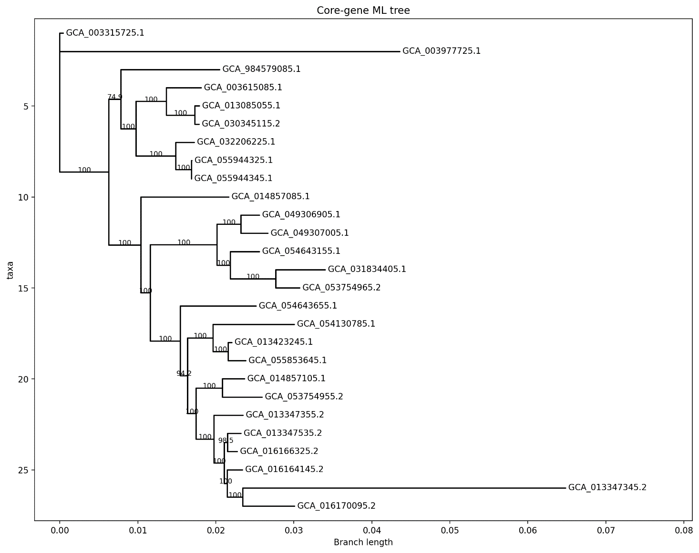
This core-genome phylogeny serves as the reference topology against which individual SIX gene trees are compared. Concordance between SIX trees and the core-genome tree would support vertical inheritance, whereas strong incongruence combined with copy-number variation, lineage-specific distribution, and synteny conservation would indicate possible duplication/loss events or movement of SIX-containing genomic regions. Therefore, the core-genome framework is essential for reconstructing the evolutionary history of SIX effectors rather than simply identifying their presence through BLAST searches.

Figure 1: Core genome phylogenetic tree

SIX gene phylogenies and evolutionary interpretation
The SIX1 phylogeny showed the highest level of diversification among the analyzed SIX genes (Figure 2). A total of 19 SIX1 homologs were identified, representing the most widely distributed SIX gene in the dataset. Multiple copies were detected in several genomes, including three copies in GCA_016166325.2, three copies in GCA_053754955.2, and three copies in GCA_053754965.2, indicating lineage-specific copy expansion. The phylogenetic tree separated SIX1 homologs into several strongly supported groups, with internal branches receiving bootstrap values up to 100, showing clear differentiation among alleles. However, SIX1 sequences did not completely follow the core-genome relationships, as homologs from distantly related lineages retained detectable similarity. The overall sequence divergence (76.70% mean identity; 23.30% divergence) indicates that SIX1 has undergone substantial diversification after duplication events.
The SIX3 phylogeny contained only three reliable homologs, showing a more restricted evolutionary distribution (Figure 3). SIX3_GCA_003315725.1_copy1 and SIX3_GCA_003977725.1_copy1 clustered closely, whereas SIX3_GCA_003615085.1_copy1 formed a separate branch, indicating lineage-specific divergence. Despite this separation, SIX3 remained relatively conserved, with 90.54% mean sequence identity and 9.46% divergence. The restricted presence of SIX3, mainly in F. oxysporum f. sp. lycopersici-associated genomes, suggests lineage-specific retention rather than broad distribution across the species complex.
The SIX7 phylogeny revealed clear evidence of gene duplication (Figure 4). Five SIX7 homologs were identified, including multiple copies in GCA_013423245.1. Among these, SIX7_GCA_013423245.1_copy2 and SIX7_GCA_013423245.1_copy4 formed a strongly supported sister group with 100 bootstrap support, indicating recent duplication within the same genome. In contrast, SIX7_GCA_003315725.1_copy1 and SIX7_GCA_003977725.1_copy1 clustered separately, reflecting lineage divergence. SIX7 showed relatively low divergence (91.07% mean identity; 8.93% divergence), suggesting that duplicated copies remain evolutionarily conserved.
The SIX10 phylogeny showed a relatively conserved evolutionary pattern (Figure 5). Three retained SIX10 homologs were analyzed, including copies from GCA_003315725.1, GCA_003977725.1, and GCA_013423245.1. The GCA_013423245.1_copy1 homolog formed a separate branch, while the other two copies showed closer similarity, indicating lineage-specific divergence. SIX10 sequences showed high conservation (94.18% mean identity; 5.82% divergence), suggesting fewer duplication events compared with SIX1 and SIX7.
Comparison of SIX phylogenies with the core-genome tree shows that SIX evolution is not entirely explained by vertical inheritance. SIX1 and SIX7 show clear evidence of lineage-specific expansion through duplication, while the restricted distribution of SIX3, SIX5, SIX10, and SIX12 suggests selective retention and possible loss events. Several SIX variants are highly similar despite occurring in genomes with different core-genome backgrounds, indicating that their evolutionary history may involve processes beyond simple organismal divergence. However, because gene-tree incongruence alone cannot distinguish horizontal transfer from duplication/loss, these patterns require confirmation through the SIX7–SIX10–SIX12 synteny analysis.

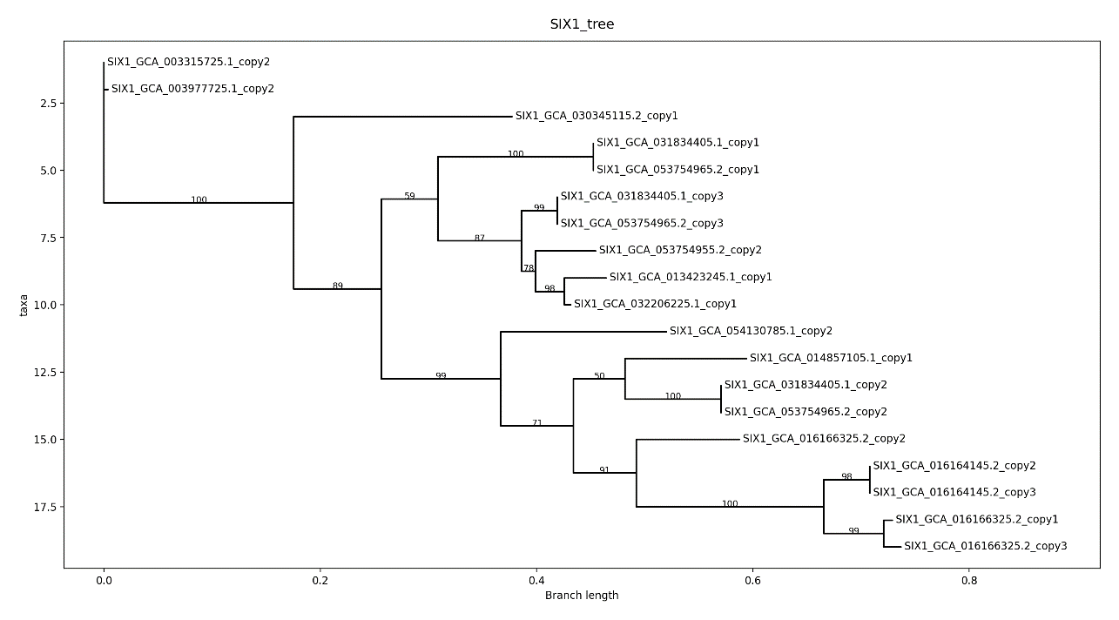
Figure 2: SIX1 phylogeny tree
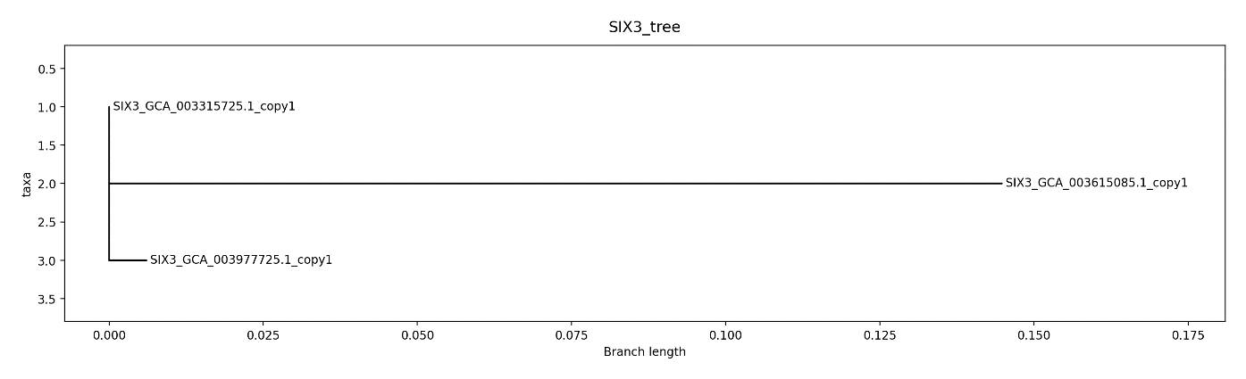

Figure 3: SIX3 phylogeny tree
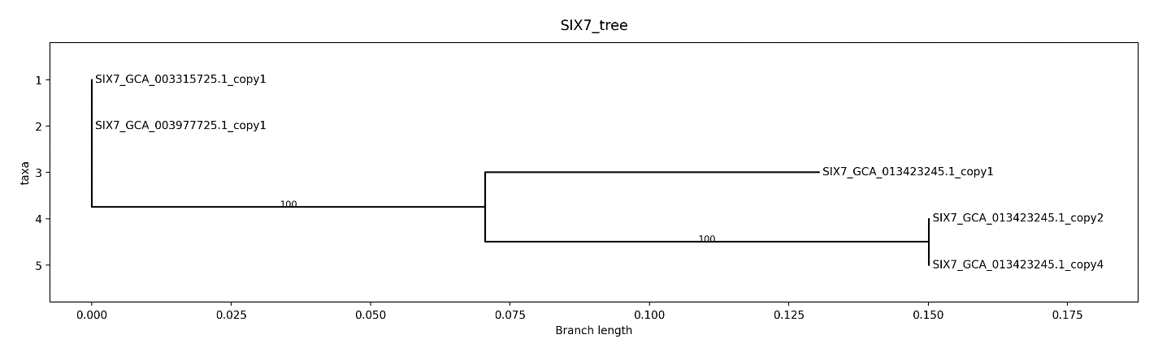
Figure 4: SIX7 Phylogeny tree
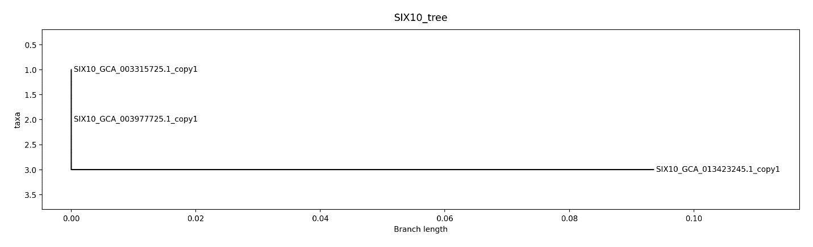
Figure 5: SIX10 phylogeny tree

Comparative synteny analysis of the SIX7–SIX10–SIX12 genomic region
The SIX7–SIX10–SIX12 region was analyzed to determine whether these effector genes are maintained as a conserved genomic block or represent independently evolving loci (Figure 6). In Fol4287 (GCA_003315725.1), the region is organized as SIX10–SIX12–SIX7 on contig QESU01000255.1. SIX12 is positioned between SIX10 and SIX7, separated by approximately 1,227 bp between SIX10 and SIX12 and 2,311 bp between SIX12 and SIX7. Although SIX12 contains a premature stop codon and is classified as pseudogenized, its physical position within the cluster is conserved.
A comparable three-gene block was identified in race 3 (GCA_003977725.1) on contig CM012196.1, where the arrangement is reversed (SIX7–SIX12–SIX10). The distances between adjacent genes are maintained, with approximately 2,311 bp between SIX7 and SIX12 and 1,227 bp between SIX12 and SIX10, matching the Fol4287 configuration in opposite orientation. Flanking-sequence comparison further supports conservation of the entire locus rather than only individual genes. The Fol4287 and race 3 regions show 99.94% identity across an approximately 15 kb window, including the SIX genes and surrounding sequences, forming a continuous conserved block.
The lini lineage (GCA_013423245.1) also retains a linked SIX7–SIX12–SIX10 arrangement on contig CM023981.1, although with altered spacing (906 bp between SIX7 and SIX12 and 1,899 bp between SIX12 and SIX10). In addition, lini contains a second SIX7/SIX10-associated region approximately 3.7 Mb away from the main cluster but lacking SIX12, indicating lineage-specific duplication and rearrangement of the SIX region.
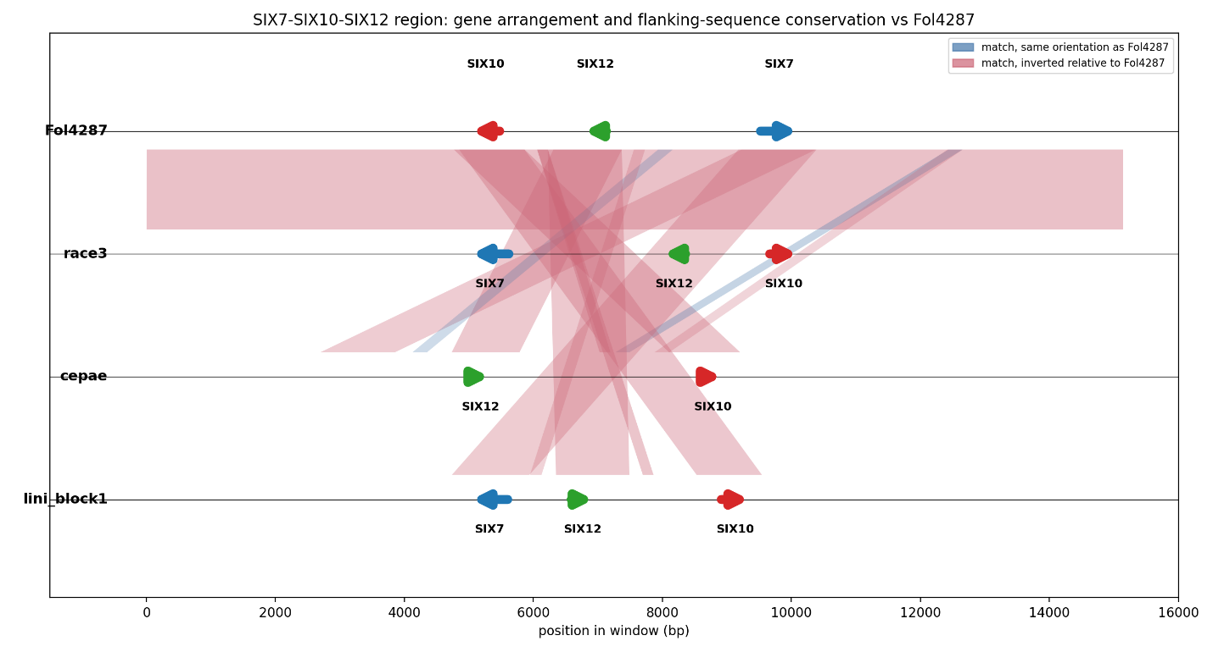

Figure 6: Synteny analysis for SIX7–SIX10–SIX12 region

In contrast, the cepae lineage (GCA_003615085.1) contains only a partial version of the cluster. SIX12 and SIX10 remain linked on contig MRCU01000021.1, separated by approximately 3,241 bp, whereas no SIX7 copy was detected in this region. This pattern is consistent with lineage-specific loss of SIX7 or incomplete retention of the original cluster.
The conserved gene order, physical proximity, and extended flanking-sequence similarity indicate that SIX7, SIX10, and SIX12 are maintained as a linked accessory genomic region rather than evolving as completely independent genes. The fragmented but recognizable similarity in cepae and lini contrasts with the unusually high conservation between Fol4287 and race 3. This pattern suggests that the locus has experienced structural changes including duplication, deletion, and rearrangement. The Fol4287–race 3 region represents the strongest candidate for recent region-level movement or unusually strong shared retention; however, synteny and gene-tree incongruence alone cannot confirm horizontal transfer without additional evidence.

Integrating SIX evolution with host association:
SIX3, SIX5, SIX7, SIX10, SIX12: tied to host, but not by simple inheritance
SIX3, SIX5, SIX7, SIX10, and SIX12 showed a restricted distribution pattern across the genome panel. These genes were mainly detected in three groups: the F. oxysporum f. sp. lycopersici isolates Fol4287 and race3 (both tomato-associated), FoC_Fus2 (f. sp. cepae, onion-associated), and the lini isolate (flax-associated). These genes were absent from 22 of the 27 genomes, and all genomes carrying these genes were associated with hosts historically linked with SIX-mediated pathogenicity.
The core-genome phylogeny does not support simple vertical inheritance of this SIX repertoire. Fol4287 and race3 occupy separate basal positions in the core tree rather than forming a recent sister group. FoC_Fus2 is located within Clade A, whereas lini is nested within Clade B together with FO12 and phaseoli isolates. Therefore, the presence of these SIX genes across these lineages cannot be explained by inheritance from a single recent common ancestor. The observed distribution is consistent with either lineage-specific acquisition events, movement of SIX-containing genomic regions, or a combination of both processes.
Evidence supporting movement of a larger SIX-containing region
The SIX7–SIX10–SIX12 synteny analysis provides the strongest evidence for a region-level evolutionary process involving SIX loci. Fol4287 and race 3 retain an unusually conserved accessory region containing these genes, whereas cepae and lini show more divergent versions of the same region with rearrangement and gene-content differences. This pattern supports either recent movement of an accessory region or unusually strong retention of a shared genomic segment. However, distinguishing between these possibilities requires integration of gene phylogenies, core-genome relationships, and additional evidence of genomic transfer.
Limitations of smaller SIX gene trees
Interpretation of some SIX phylogenies requires consideration of taxon sampling. SIX3 and SIX10 each contain only three reliable homologs, producing three-tip trees with limited ability to test alternative evolutionary arrangements. SIX7 contains five reliable homologs, but these represent only three genomes, since the lini isolate contributes multiple paralogous copies; genome-level sampling therefore remains similarly limited despite the larger tip count. In these cases, bootstrap values confirm the stability of observed pairwise clustering but cannot provide strong evidence for broader evolutionary relationships because only a small number of sequences are available.
SIX1 provides a stronger phylogenetic comparison because it contains a larger number of homologs. With 12 genomes carrying SIX1, the gene tree provides greater resolution and shows that Fol4287 and race3 SIX1 copies form a strongly supported cluster separated from other SIX1 homologs.

Does SIX repertoire track host, forma specialis, or evolutionary background?
The relationship between SIX repertoire and host association differs among gene families. SIX3, SIX5, SIX7, SIX10, and SIX12 show strong association with particular host-associated lineages, but these distributions do not match the core-genome relationships. The lineages carrying these genes are separated across the core tree, indicating that host association alone does not explain their evolutionary history.
SIX1 shows a different pattern. Its distribution does not correspond strongly with host or forma specialis, but instead reflects duplication, expansion, and lineage-specific loss across multiple genomic backgrounds.
The SIX repertoire is therefore influenced by multiple evolutionary factors. Different SIX genes show different relationships with host association, genome ancestry, and accessory genome evolution rather than following a single evolutionary pattern.
Evidence required to distinguish evolutionary scenarios
Vertical inheritance would require SIX presence, absence, and copy number to follow the core-genome phylogeny. Closely related isolates should contain similar SIX repertoires, and SIX gene trees should show relationships consistent with genome-level ancestry.
Duplication followed by loss would be supported by multiple copies within genomes, paralog clustering in gene trees, and patchy distribution among related isolates. The SIX1 dataset provides examples consistent with this process.
Rapid sequence divergence would require evidence that the gene is still present at the expected genomic location but has accumulated sufficient sequence changes to reduce similarity or produce an unusually long branch. Such cases require examination of local genomic context rather than interpreting absence alone.
Incomplete genome assembly must be considered when a SIX gene appears absent. Assembly fragmentation, contig boundaries, and local synteny should be evaluated before interpreting absence as biological loss, particularly because SIX genes occur on accessory pathogenicity chromosomes.
Independent movement of a single gene would require high sequence similarity between distantly related isolates while the surrounding genomic region lacks conservation. In this case, the similarity would be restricted to the gene itself rather than extending into neighboring sequences.
Horizontal transfer of a larger accessory region would require conservation of multiple linked genes together with surrounding genomic sequences between distantly related isolates. Additional support would include evidence of genomic boundaries, such as transposable elements, unusual GC composition, or structural breakpoints. The Fol4287–race3 SIX region represents the strongest candidate for this pattern because it combines high flanking-region similarity, SIX gene-tree incongruence, and repeated similarity across multiple SIX loci. Confirmation requires further analysis of the region boundaries and associated genomic features.

Main Biological Questions
1. How widely distributed are SIX1, SIX3, SIX5, SIX7, SIX10, and SIX12 across Fusarium oxysporum?
The six SIX genes show contrasting distribution patterns. SIX1 is the most widely distributed gene, detected in 12 of the 27 genomes across multiple unrelated formae speciales. In contrast, SIX3, SIX5, SIX7, SIX10, and SIX12 show restricted distributions. SIX3 occurs in three genomes, SIX10 occurs in four genomes, SIX7 occurs in three genomes with expansion to four copies in the lini isolate, SIX5 occurs in two genomes, and SIX12 is retained as a functional copy only in FoC_Fus2 with pseudogenized remnants in Fol4287 and race3.
2. Which SIX genes are broadly distributed, and which are restricted to host-associated lineages?
SIX1 shows a broad distribution without a consistent association with host or forma specialis. In contrast, SIX3, SIX5, SIX7, SIX10, and SIX12 are restricted mainly to three host-associated lineages: the tomato-associated lycopersici isolates (Fol4287 and race3), onion-associated cepae, and flax-associated lini. Their distribution corresponds more closely with specific host-associated lineages than with the overall core-genome relationships.
3. How much copy-number variation exists for each SIX family?
Copy-number variation is strongest in SIX1 and SIX7. SIX1 ranges from one to three copies depending on lineage. The highest copy numbers occur in the cubense TR4 isolates (Tw-TR4-1 and II5) and the fragariae isolates MAFF727510 and BRIP62122a, each carrying three copies. SIX7 ranges from one copy in lycopersici isolates to four copies in lini. SIX10 shows limited expansion, with additional copies detected in lini. SIX3 and SIX5 show no copy-number variation among detected homologs. SIX12 variation is mainly associated with functional status, with a retained functional copy in FoC_Fus2 and pseudogenized copies in Fol4287 and race3.
4. Do the SIX gene trees agree with the core-genome phylogeny?
The relationship between SIX gene trees and the core-genome phylogeny differs among genes. SIX5 and SIX12 cannot be evaluated through phylogeny because insufficient reliable sequences are available. SIX3, SIX7, and SIX10 were each detected in only three genomes, limiting formal topology comparison, but all show the same pattern: Fol4287 and race3 sequences are nearly identical, whereas the third lineage-specific copy is more divergent.
SIX1 provides the strongest comparison because it contains sufficient taxa for a resolved phylogeny. The SIX1 tree does not follow the core-genome relationships. Fol4287 and race3 SIX1 copies form a strongly supported cluster separated from other SIX1 homologs, while additional paralog relationships reflect lineage-specific duplication events rather than genome-wide ancestry.
5. Which SIX genes show the strongest evidence of evolutionary independence from the core genome?
The strongest evidence comes from the SIX7/SIX10 region because gene-tree relationships are supported by flanking-region conservation and synteny analysis. However, the same Fol4287–race3 similarity pattern is also observed in SIX1, SIX3, and the SIX12 pseudogene. The repeated occurrence of near-identical SIX sequences between these two isolates despite their separation in the core-genome phylogeny indicates that SIX evolution is not always predicted by organismal relationships.
6. Is there evidence for lineage-specific duplication or gene loss?
Yes. SIX1 provides the clearest examples. The cubense TR4 isolates share matching paralog patterns, consistent with inheritance of an earlier duplication event. In contrast, MAFF727510 and BRIP62122a each contain three SIX1 copies, but their copies do not cluster together, indicating independent duplication events within the same forma specialis. Loss is suggested by GL1381, which lacks SIX1 while related fragariae isolates retain it; however, assembly quality must be considered before confirming true absence.
7. Is the SIX7–SIX10–SIX12 region conserved as a linked block across lineages?
Yes. The synteny analysis shows that SIX7, SIX10, and SIX12 are maintained as a linked region in genomes containing multiple members of the cluster. The region shows strong conservation between Fol4287 and race3, whereas cepae and lini show more divergent but recognizable syntenic relationships. The observed differences in gene content and arrangement indicate subsequent rearrangement, duplication, and loss events.
8. Is there evidence that individual genes or larger regions have moved between divergent isolates?
The Fol4287–race3 SIX7/SIX10/SIX12 region represents the strongest candidate for movement of a larger accessory genomic region because the genes and surrounding sequences show unusually high similarity compared with their core-genome relationship. Similarity at additional SIX loci suggests that this pattern is not restricted to a single genomic region. However, gene-tree incongruence alone cannot distinguish horizontal transfer from other processes such as duplication, loss, or retention of ancestral accessory regions.
9. Are particular SIX repertoires associated with particular hosts or formae speciales?
SIX3, SIX5, SIX7, SIX10, and SIX12 show strong association with specific host-associated lineages, particularly tomato-, onion-, and flax-associated isolates. SIX1 does not show a comparable host or forma specialis pattern and instead displays a broad distribution shaped by duplication and loss.
10. What evolutionary model best explains the distribution of these six effectors?
The six SIX genes do not follow a single evolutionary model. SIX3, SIX5, SIX7, SIX10, and SIX12 show restricted distributions associated with host-adapted lineages and linked accessory-region evolution. SIX1 shows a broader evolutionary history involving duplication, retention, and lineage-specific loss. The repeated close relationship between Fol4287 and race3 across multiple SIX loci represents the strongest deviation from the core-genome pattern and indicates that accessory genome history contributes substantially to SIX diversification.

Table 5: Sequence Divergence Summary

# | Gene | Number_of_  sequences | Alignment_length (aa) | Variable_sites | Mean_pairwise_  identity_% | Mean_  divergence_%
0 | SIX1 | 19 | 284 | 146 | 76.70 | 23.30
1 | SIX3 | 3 | 163 | 23 | 90.54 | 9.46
2 | SIX5 | 2 | 119 | 0 | 100.00 | 0.00
3 | SIX7 | 5 | 220 | 32 | 91.07 | 8.93
4 | SIX10 | 3 | 149 | 13 | 94.18 | 5.82
5 | SIX12 | 5 | 429 | 23 | 97.13 | 2.87

Note: sequence counts and divergence statistics in this table are computed from all detected homologs per gene, including pseudogenized and truncated copies, and therefore differ from the retained-copy counts in Table 4 and from the homolog counts used for tree building (Section 2.5). This is why SIX12 shows five sequences here despite only one non-pseudogenized functional copy being available for phylogenetic reconstruction.
References
Houterman, P. M., Cornelissen, B. J. C., & Rep, M. (2008). Suppression of plant resistance gene based immunity by a fungal effector. PLoS Pathogens, 4(5), e1000061.
Jangir, P., Mehra, N., Sharma, K., Singh, N., Rani, M., & Kapoor, R. (2021). Secreted in xylem genes: Drivers of host adaptation in Fusarium oxysporum. Frontiers in Plant Science, 12, 628611.
Li, J., Fokkens, L., Conneely, L. J., & Rep, M. (2020). Partial pathogenicity chromosomes in Fusarium oxysporum are sufficient to cause disease and can be horizontally transferred. Environmental Microbiology, 22(12), 4985 to 5004.
Ma, L. J., van der Does, H. C., Borkovich, K. A., Coleman, J. J., Daboussi, M. J., Di Pietro, A., Dufresne, M., Freitag, M., Grabherr, M., Henrissat, B., Houterman, P. M., Kang, S., Shim, W. B., Woloshuk, C., Xie, X., Xu, J. R., et al. (2010). Comparative genomics reveals mobile pathogenicity chromosomes in Fusarium. Nature, 464(7287), 367 to 373.
Rep, M. (2005). Small proteins of plant pathogenic fungi secreted during host colonization. FEMS Microbiology Letters, 253(1), 19 to 27.
van Dam, P., Fokkens, L., Schmidt, S. M., Linmans, J. H. J., Kistler, H. C., Ma, L. J., & Rep, M. (2016). Effector profiles distinguish formae speciales of Fusarium oxysporum. Environmental Microbiology, 18(11), 4087 to 4102.

